**Trial 1: excretion and transmission of wild-type PT21/28 strain 9000 and wild-type PT32 (strain 10671)**

We have now completed transmission and excretion studies for a wild-type PT21/28 strain (9000) and a wild-type PT32 *E. coli* O157 strain (10671). For each strain 16 Holstein-Friesian calves, screened as negative for *E. coli* O157 on 4 separate occasions (8, 9, 10, and 11 weeks of age) by both immunomagnetic separation (IMS) and quantitative PCR techniques entered the Moredun High Security Unit, and were assigned to three separate rooms (C1 (n=6), C2 (n=5), C3 (n=5)). Additional *E. coli* O157 negative spare calves (n=5 for the PT21/28 challenge study and n=4 for the PT32 challenge study) acted as unchallenged controls for immunological studies and were housed in the Moredun farm at CL2.

All six calves in room C1 were orally challenged with ~3 × 109 CFU *E. coli* O157 marked with nalidixic acid resistance and levels of bacteria within the faeces monitored on a daily basis using nalidixic acid containing Sorbitol MacConkey agar (NAL-SMAC) plates. At 5 days post-challenge, one colonized calf each from C1 was moved into pens C2 and C3 to act as a source of infection for the naive in-contact sentinel calves, and levels of *E. coli* O157 challenge strain within faeces and the environment were monitored on a daily basis.

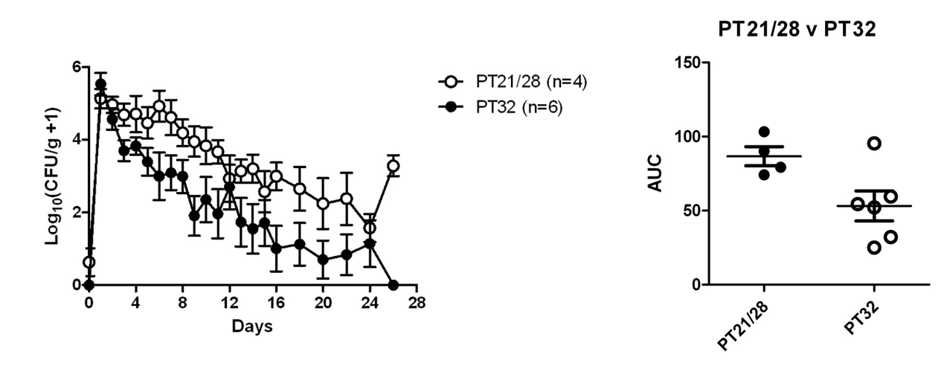We observed higher levels of shedding in calves orally challenged with the PT21/28 strain compared to the PT32 strain, consistent with previous epidemiological evidence (Fig.1).

**Figure 1: Levels of *E. coli* O157 within faeces of calves either orally challenged with either a PT21/28 or PT32 strain of *E. coli* O157.** (A) Mean daily bacterial shedding from calves orally challenged with ~3 x 109 CFU of either a PT21/28 (9000) or a PT32 (10671) *E. coli* O157 strain. (B) Total bacterial shedding over the study period, as determined by the area under the curve (AUC) for calves challenged with the PT21/28 or a PT32 *E. coli* O157 strain.

For the PT21/28 strain, all (10/10) sentinel calves became positive for the challenge strain on at least one occasion, and one of the sentinel calves shed high (>104) levels of the challenge strain for a three day period (Fig. 2A). In contrast, for the PT32 strain the challenge strain was not detected in any of the sentinel calves (Fig. 2B). Therefore, a highly significant difference in transmission was observed between the PT21/28 and PT32 wild-type strains (Table 2). Furthermore, environmental levels of each strain mirrored the mean shedding level of calves within the pen suggesting little replication of the bacteria within the environment (Fig. 2).

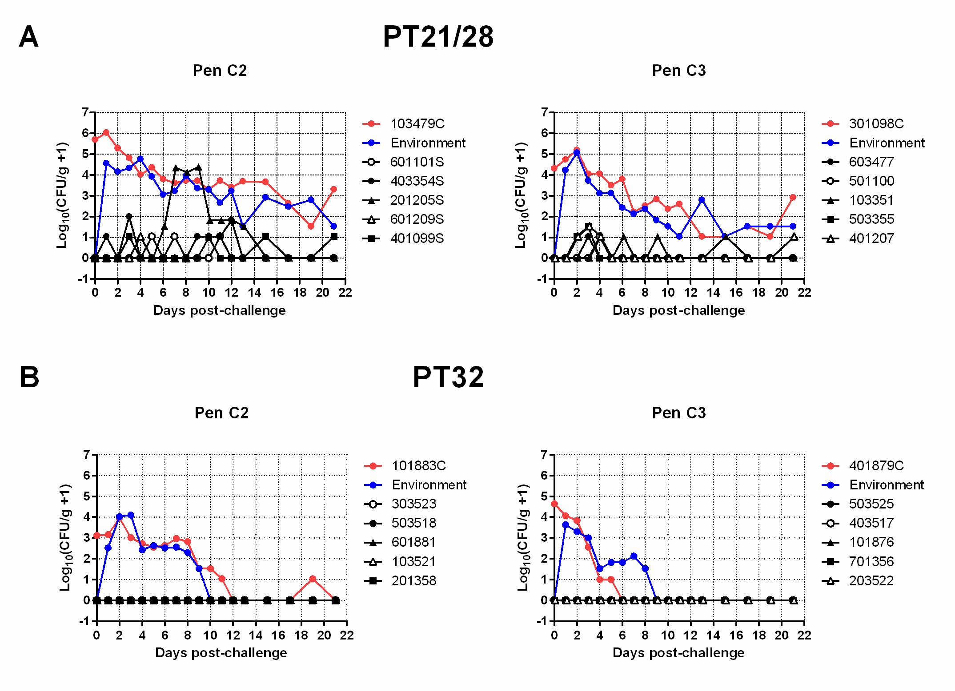

**Figure 2: Levels of *E. coli* O157 within faeces of naive sentinel calves in contact with calves super-shedding either a PT21/28 or PT32 strain of *E. coli* O157.** Calves 103479C and 301098C were orally challenged with either (A) wild-type PT21/28 *E. coli* O157 strain 9000 (calves 103479C and 301098C) or (B) wild-type PT32 *E. coli* O157 strain 10671 (101883C and 401879C). Five days later experimentally infected calves were moved into rooms containing five naive sentinel calves each (one experimentally infected calf per pen). Levels of the challenge strain within the faeces of sentinel calves and the environment were determined over a 21 day period. PT21/28 challenge strain was detected in the faeces of all sentinel calves on at least on occasion with one sentinel calf (201205S) shedding high (>104 CFU/g faeces) levels of bacteria for a three day period. PT32 challenge strain was not detected in any of the sentinel calves during the study period.

**Trial 2: excretion and transmission of wild-type mutant PT21/28 strain 9000 with functional *stx2a* gene**

Further analysis of the Stx2a-ISEc8 repaired strain used in cattle Trial 1 indicated that while levels of Stx2a protein were increased following removal of ISEc8, verocytotoxicity levels were not increased, suggesting that the Stx2a produced by this strain was not functionally active. Sequencing of the Stx2a A and B subunits identified a single base change within the B subunit in an area which was likely to be involved in binding of the Stx2a to the Gb3 receptor. Therefore, a further strain was generated (Stx2a-ISEc8 repaired strain 2.0) in which the base change in the B subunit was reverted back to the original base. This now resulted in a PT21/28 strain which produced functional Stx2a (Fig 3).

M:\E5915 FSA TRIAL 4\Repaired 9000 St2 expression and toxicity.tif

**Figure 3.** Stx2 protein expression (A) and verotoxicity (B) of the wild-type PT21/28 strain (WT 9000) and the Stx2a-ISEc8 repaired strain 2.0 (9000 Stx2a Repaired) indicating increased Stx2 expression and verotoxicity of the repaired strain.

**B**

**A**

This Stx2a-ISEc8 repaired strain 2.0 was subsequently used to perform a transmission study (Trial 2) in which 17 Holstein-Friesian calves, screened as negative for *E. coli* O157 by IMS and qPCR, were assigned to three separate rooms (C1-3) within the Moredun High Security Unit (C1 n=7, C2 n=5, C3 n=5). An additional five *E. coli* O157 negative calves acted as unchallenged controls for immunological studies. Calves in C1 were orally challenged with 109 CFU Stx2a-ISEc8 repaired strain 2.0. At day 5 post-challenge one colonized calf each from C1 was moved into pens C2 and C3 to act as a source of infection for the naïve in-contact sentinel calves and levels of *E. coli* O157 challenge strain within the faeces and the environment were monitored on a daily basis over a 25 day period. The transmission results are shown in Fig 4. 10/10 of the naïve sentinels became colonized with the challenge strain and 9/10 of these calves shed the challenge strain at super-shedding levels (>103 CFU/g). Interestingly, the mean daily shedding of the Stx2a-ISEc8 repaired strain 2.0 was similar to the wild-type strain (Fig. 5).

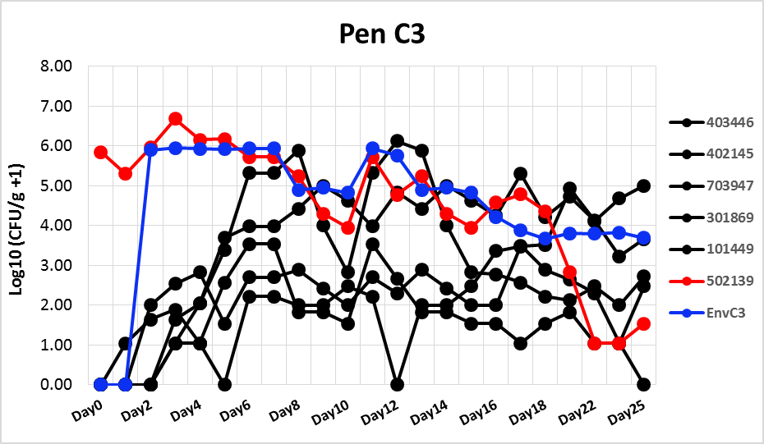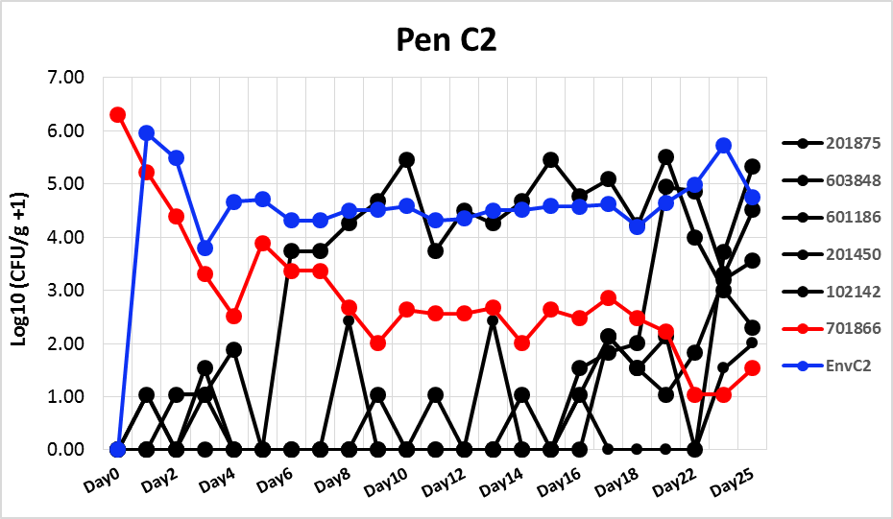

**Figure 4.** Transmission of Stx2a-ISEc8 repaired strain 2.0 to naïve in-contact sentinels. One calf each previously orally challenged with Stx2a-ISEc8 repaired strain 2.0 and shedding the bacteria at ~106 CFU/g faeces was moved into two rooms of 5 *E. coli* O157 naïve sentinel calves and levels of bacteria within the faeces and the environment were monitored over a 25 day period. Red dots/lines indicate shedding from the orally challenged calves; blue dots/lines indicate levels of challenge strain within the environment; black dots/lines indicate bacterial levels within the naïve in-contact sentinels.

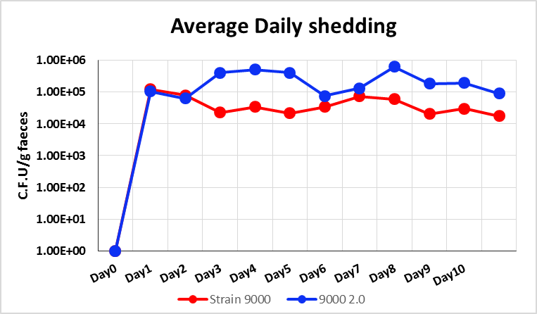

**Figure 5.** Mean bacterial shedding from calves challenged with wild-type PT21/28 strain (Strain 9000, red) or an isogenic Stx2a-ISEc8 repaired strain 2.0 (9000 2.0) following oral challenge with ~109 CFU of each strain.

These results suggest that a functional Stx2a gene is associated with higher transmission rates, and importantly the generation of new super-shedding calves. As super-shedding cattle are responsible for most cattle-to-cattle transmissions (Matthews et al 2006) this also **suggests that *stx2a* carriage plays an important role in persistence of *E. coli* O157 in cattle populations**. The data is currently being compiled for statistical analysis by BioSS and for use in parameterising mathematical models of *E. coli* transmission in cattle under Deliverable 3.2.